My Year 3 Journey…

This booklet belongs to: __________________________

In September I am going to be in Year 3. This is what my school looks like.
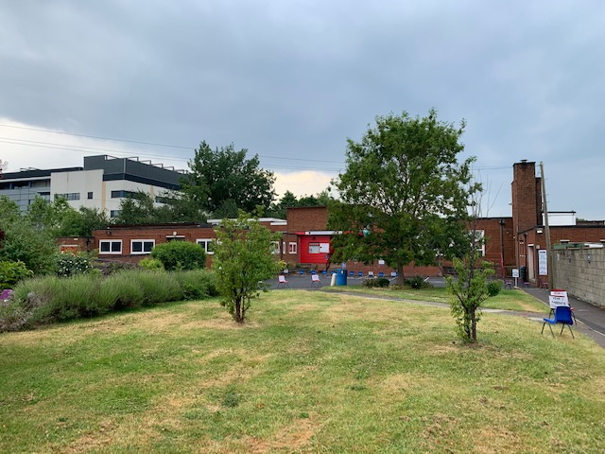
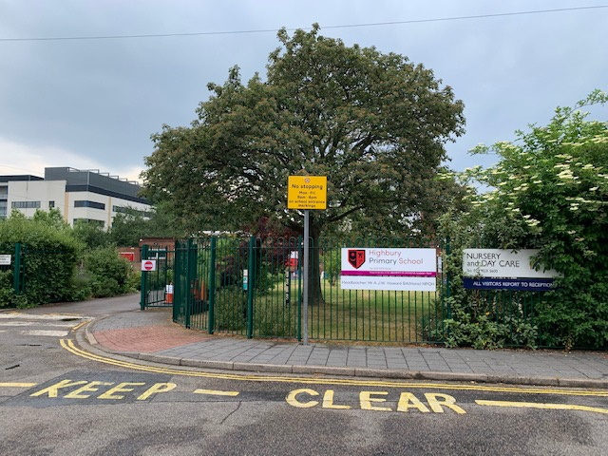

Mrs James is the Assistant Headteacher.
Mr Howard is the
Headteacher.
Mrs Boulton is the Deputy Headteacher.

These are my teachers…

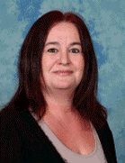
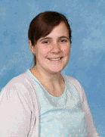

Mrs Clark
Mrs Bowdery
Mrs Chaplen

We are all very
excited to do
lots of learning
with you in
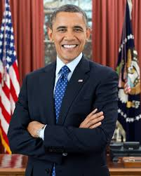
September.

I will be in Obama Class.

This is how I get into the school.
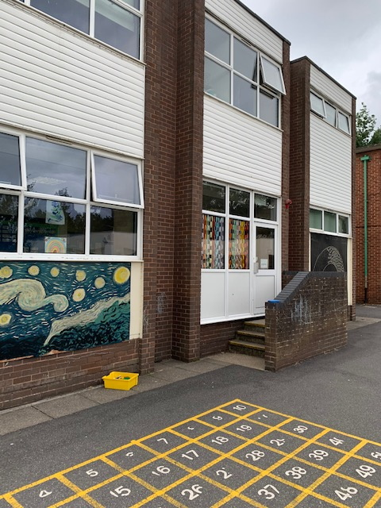

This is my classroom where I will get to do my learning.
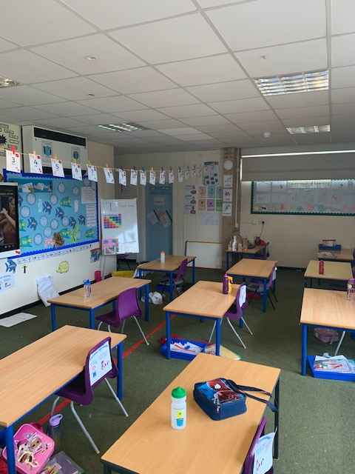

These are the toilets which Year 3, 4, 5 and Year 6 share. There are sinks for me to wash my hands and hand towels for me to dry my hands with. I must remember to shut the door!

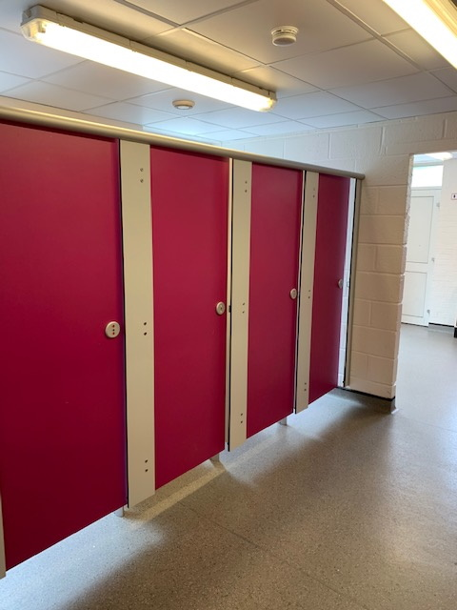
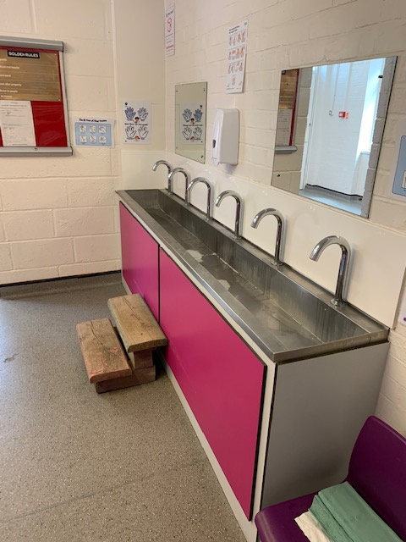

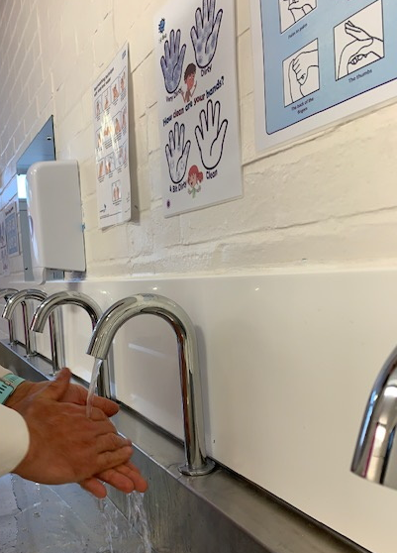
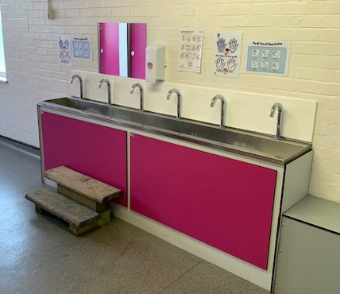

This is the hall, where I usually have my lunch and go to assemblies…However, I will be having my lunch in my classroom and we will have whole school virtual assemblies.

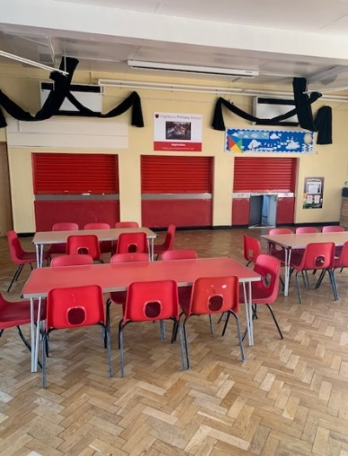
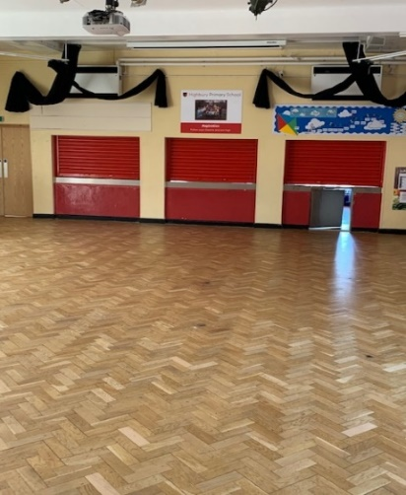

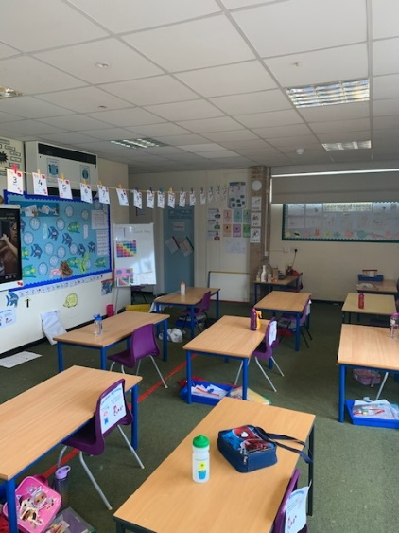

After I have eaten my lunch, I will get to play in my class outside area. I will get to play with the other children in my class.
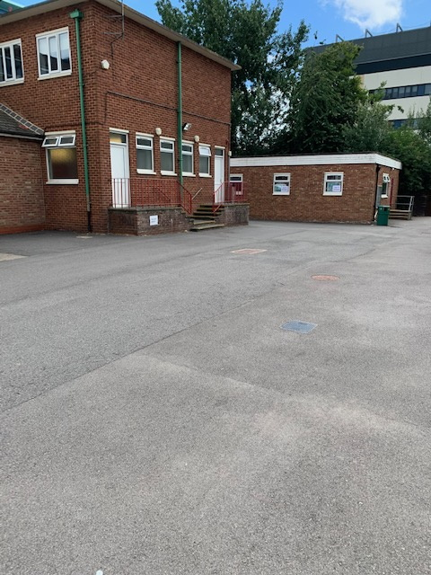
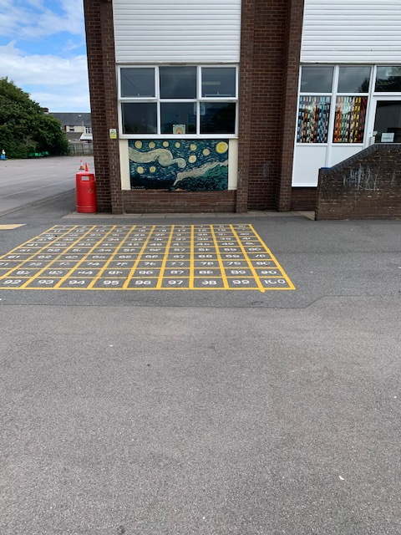

Here is our school office and medical room. Our medical room is now called the ‘Nightingale Room’.
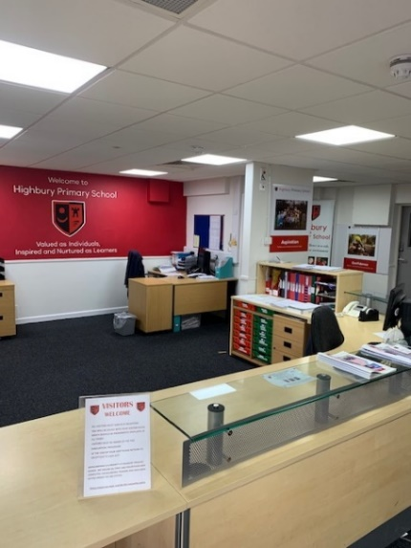
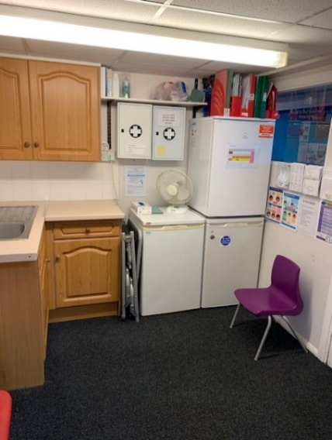
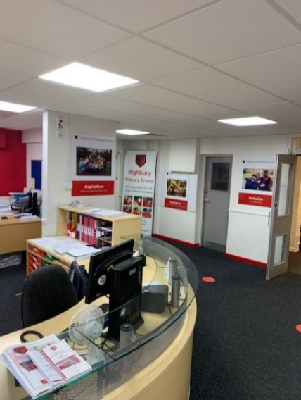

Many children feel worried and maybe excited when they are starting something new. It is helpful to remember what you know will be the same as before. It is ok to ask questions. Your parents and teachers will help you.
We hope you have a great summer and we cannot wait for September!
Bye from your teachers and our School Value heroes!
